Building a Stronger Foundation
^{A Research Paper}

^{Adrianna L. Nixon}
National Forum for Black Public Administrators
^{Mentorship Program}
²⁰¹⁸

Table of contents

Introduction & Purpose……………………………………………………………………….3

Research Methodology……………………………………………………………………….5

Partnership Opportunities…………………………………………………………………….7

The Organizations…………………………………………………………………………….8

SECTION I: ROCK THE WALK 2018
Background……………………………………………………………………………10
Event Outline………………………………………………………………………….12
Event Partnerships……………………………………………………………………14
Event Marketing/Promotion………………………………………………………….15
Testimonial…………………………………………………………………………….16
Recommendation……………………………………………………………………...17

SECTION II: LIFTING FAMILIES TOGETHER (LFT)
Background…………………………………………………………………………..…19
Lifting Families Together Health Fair & Walkathon (5k) ……………………….….20
Lifting Families Together Annual Evening at the Gala (2018) ……………………20
Recommendation………………………………………………………………………20

Conclusion……………………………………………………………………………………....22

Acknowledgments………………………………………………………………………………23

References…………………………………………………………………………………..…..24
Introduction

HIV/AIDS is one of the most feared diseases in the world today. It’s not talked about so people are uneducated about it. According to the Centers for Disease Control and Prevention (CDC) in 2015, youth aged 13 to 24 accounted for more than 1 in 5 new HIV diagnoses. There were 8,807 cases. In 2016 the population of Harris County, was reported to be 4,589,928. And, of that population there were 1,205 new HIV/AIDS diagnosis in the county overall.
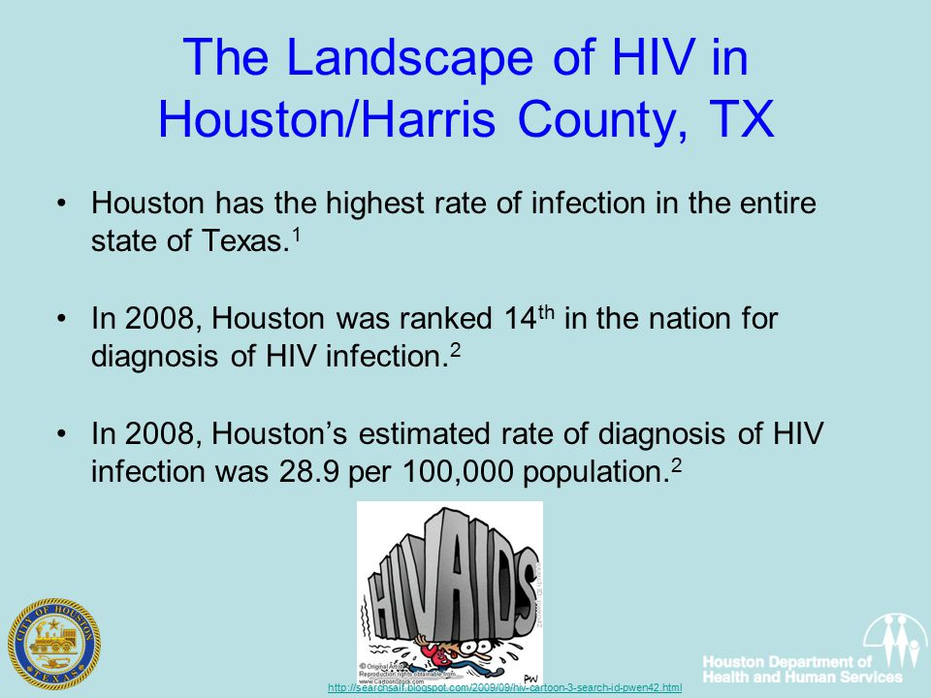
FIG 1: Landscape of HIV in Houston/Harris County, TX
There have been many prevention efforts available to support the community. The more citizens are aware of the disease, the more they can prevent contraction and the spread of it. These programs are available in all parts of the world and offer different types of services such as mobile testing, support services, financial assistance, education and engagement and more. These initiatives are integral in helping to spread the word about HIV/AIDS and other diseases.

Purpose
This report will discuss some of these organizations that target prevention in the Houston/Harris County region. Each organization was established as a resource to individuals newly diagnosed, living with the disease and to spread the word about the disease, erase negative stigma and to raise money to help individuals living with it. Each organization targets certain age demographics and offers services as such.
This report will evaluate the organizations’ community outreach initiatives and identify ways to improve the concept by including economic factors that can benefit the organization and incorporating partnerships to help with funding the initiative. An evaluation will be performed by the NFBPA mentorship program participant and will be solely in her opinion.

Research Methodology

Survey Questions
To complete the overall evaluation, A survey was sent to each organization and asked the following questions:
- What is the program name and scope? When was the program established?
- How is the program managed?
- What are some benchmarks, successes of the program?
- What is your targeted age demographic for these programs?
- How does your organization evaluate program operations and is that process internal/external?
- Are you open to receiving feedback from other sources such as an independent audit (if so, please explain)?
Selected Organizations
The organizations/program(s) selected for evaluations is one regionally known organization, Aids Foundation Houston (AFH) and its program AIDS Walk Houston 2018 and one fairly-new organization, Lifting Families Together (LFT) who coordinates several health fairs and assistance initiatives that benefit the community throughout the year. Selecting to evaluate an established non-profit organization’s programs along with an up and coming one provides more in-depth analysis of programs that could be expanded to grow not only regionally, but nationally as well.

Materials/Data Collection
The survey was created using Google Docs. The survey link was copied from Google Docs and sent via email to organization representatives. Each survey question was formulated to receive as much information regarding the organizations successes, programs, and tracking systems. These are key tools to ensuring that the program evaluation is a success and produces results that could be shared across the globe. Data from the surveys will be collected in Google Docs and used to assist with the evaluation of the organizations and its programs. Videos containing testimonials from AIDS Walk 2018 volunteers and participants and testimony from Lifting Families Together board members will be evaluated as well.

Partnership Opportunities
Partner is defined as “a person who takes part in an undertaking with another or others. Especially in a business or company with shared risks and profits.” Partnership is defined “as an association of two or more people as partners.”
The ability to build and maintain relationships in business has always been a key element associated with success. Although these organizations are successful, they can be strengthened by building partnerships with other nationally known organizations such as the National Forum for Black Public Administrators (NFBPA). Building these partnerships will be integral in boosting the organizations’ brand and serving more of the community.
Building strong partnerships contain these key components:
- Leadership
- Common Understanding
- Purpose
- Culture & Values
- Learning & Development
- Communication
- Performance Management
This report will discuss how these organizations could utilize these key components to strengthen and/or build new partnerships to aide in the succession rate of the referenced events in this report.
The Organizations
The two 501c3 organizations featured in this report are the AIDS Foundation Houston, Inc. (AFH) and Lifting Families Together.
AIDS Foundation Houston, Inc. was founded in 1982 as Texas’ first organization dedicated to HIV prevention education and services. The mission statement of AFH is to lead the innovative efforts in the prevention of new HIV infections and empower individuals, families and communities affected by HIV/AIDS to create and sustain healthy lives. AFH offers several community mobilization sessions that aim to serve as support groups for individuals living with the disease and for their family members.
AFH organization is comprised of several different initiatives such as the Prison Initiative, Lifeguard program, the Get Started program and Youth Focus programs. They host a slew of activist events such as the Rock the Walk AIDS Walk which will be evaluated in the report. AFH also offers free HIV testing and STD screenings.
Lifting Families Together (LFT) was founded by President and Founder, Ava Holland in 2015. Ava said her inspiration for starting the organization came from a young boy named Ethan who had a heart transplant in December of 2012. Ethan is doing well and is now enrolled in school. The mission statement of LFT is to provide a community vehicle to help maintain wholesome family relationships in a supportive environment and to improve the quality of life for children with health care issues.
LFT was founded to serve youth ages 0-18 years old in the Harris, Fort Bend and Brazoria counties by addressing four service areas for families in need:
- Counseling and Case Management Services – Focusing on Family Counseling for parents, siblings and friends of children with specialized health issues.
- Educational Forums – Focus is to address the specific health issue involved, including care and safety issues of the child with special health issues.
- Financial Services – Focus on financial support for families with household bills, such as mortgage, utilities, car notes, and specialized transportation for kids with health issues.
- Life Skills – Focus is on healthy meal preparation and planning, personal care, plan and coordinate recreational activities and community outings.
Some benchmarks and successes of the organization includes partnership with the Texas Children’s Hospital West, sponsoring sickle cell holiday party yearly serving over 20 plus families, serving over 100 families on Christmas Day for the past two years, sponsoring free health fair and free children’s activities which includes screening for high blood pressure, diabetes and others. LFT has provided several educational forums to families. LFT receives consumer feedback regarding their programs and services via surveys from families served and internally from volunteers.

PART I: ROCK THE WALK: AIDS WALK HOUSTON 2018

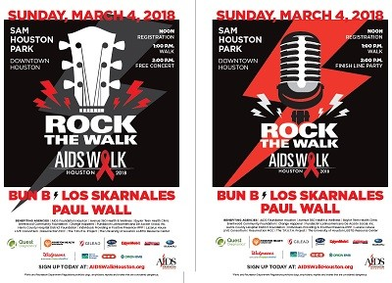
Rock the Walk 2018 Official Posters
Background
AIDS Walk Houston 2018 is a community-wide event that attracts thousands of Houstonians each year. For the past 29 years, the Walk has been and remains Houston’s greatest response I the fight against HIV/AIDS. The 1.8-mile (3k) walk is produced by AIDS Foundation Houston, Inc. and benefits local AIDS Service Organizations striving to make an impact in the fight against AIDS while providing vital social services to Houstonians living with HIV/AIDS. The proceeds that participants raise support over 90,000 Houstonians each year, providing them with, education, pediatric programs, housing, food, medical care, counseling and job training.
Participants may register as individuals or as a team to participate in the walk. Participants are also able to set a fundraising goal and raise funding utilizing their own sponsorship page, connected to the AFH website. Every year, close to 10,000 men, women and children along with 13 benefiting AIDS Service Organizations gather to raise money for this great cause.
All proceeds that are raised are provided to thirteen pre-selected non-profit organizations that support HIV/AIDS initiatives.
Those organizations are:
- AIDS Foundation Houston, Avenue 360 Health & Wellness, Baylor Teen Health Clinic, Brentwood Community Foundation, Change Happens!, Fundación Latinoamericano De Accion Social, Inc., Harris County Hospital District Foundation, Individuals Providing A Positive Presence-IPPP, Lazarus House LIVE Consortium, Resurrection MCC, The T.R.U.T.H Project and the University of Houston LGBTQ Resource Center.

Outline for Walk
This year, AFH took a different approach with the walk and included a free concert featuring a diverse lineup of local bands and celebrity emcee’s. AIDS Walk Houston 2018 took place on Sunday, March 4 beginning at noon and was held at the Sam Houston Park – Downtown Houston. Registration began at noon with the walk starting at 1 p.m. Then, from 2 p.m. to 5 p.m. the free concert featuring Bun B., Paul Wall, Los Skarnales and DJ Gracie Chavez began.
The event featured numerous informational booths, free activities for children, snacks and much more. See FIG. 2 for main event outline:
Rock the Walk: AIDS Walk 2018 |  | Sunday, March 4, 2018
Registration | Noon | Registration Tent – Receive payments/verify donation totals  Go Green Tent – Online donation fundraising verification only
Walk Kick-Off | 1 p.m. | 1.8-mile (3k)
Concert | 2 p.m. | Feature Bun B, Paul Wall, Los Skarnales and DJ Gracie Chavez

FIG 2: Rock the Walk: AIDS Walk 2018 Outline

Once participants’ fundraising initiatives were verified, the participant was provided with a voucher to receive their incentives from the Incentives Tent conveniently located on the premises. FIG 3 shows a breakdown of these incentives and the sponsorship level required to receive them.

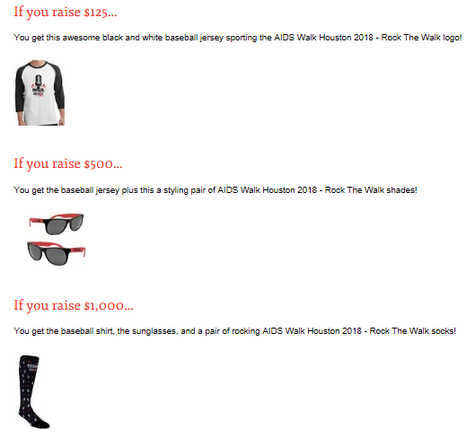

FIG 3: Rock the Walk: AIDS Walk 2018 Incentives

Event Partners
AIDS Walk Houston 2018 included partnerships from:
- Houston Health Department
- Gilead
- Avita Pharmacy
- Exxon Mobil
- Gillman
- Subaru
- Walgreens
- Green Mountain Energy
- H-E-B
- Orion EMS
These partnerships provided both monetary and materialistic donations for the AIDS Walk 2018. These sponsorships made it possible to provide the many children’s activities and booths at the event. These partnerships made it possible to provide participants with water and other refreshments during the walk and the event, itself. This event also included several volunteers who donated their time to man booths, activities and assist with event set-up/break down. Volunteers were an integral part to the success of the event overall.

Event Marketing/Promotion
The event was marketed/promoted using social media platforms (Facebook, Instagam, Twitter) and through an event page linked to the main website. Event partners were also provided with social media tool kits which included event verbiage, social media platform statistics, event hashtags, goals, tactics and more. These kits provided information that would help the participant to solicit for donations and help the participant to spread the word regarding the event.
Each registered participant was provided with their own fundraising website that was featured on the main site. This website afforded the participant the opportunity to share their fundraising goal and to solicit donations online. This method also provided an opportunity for individuals who were unable to join the walk to raise money to support the cause. AFH was able to accomplish this by using an online fundraising software that allowed them to generate reports and track donation progresses.
The 12 benefiting agency’s including AFH promoted the event using their social media platforms. One agency, T.R.U.T.H, created an event video that included information on the walk, footage from last years’ event and participant testimonies. The video was featured on the agency’s YouTube channel, as well as, on their primary website. The agency used these methods to encourage the community to come out to support and participate in the walk.
See appendix A attached to the report for a full visual of the social media tool kit.

Testimonial
An interview was conducted with a walk participant and the following testimony was provided.
Interviewee: Fran – Houston, TX
Interviewer: NFBPA Mentor Program Participant
Interviewer: Was this your first year participating in the AIDS Walk Houston initiative?
Fran: “No, this was my second year participating. Would have done it the year before, but it rained, and I didn’t want to walk in the rain.”
Interviewer: Why did you walk today?
Fran: “I walked in remembrance to my mom who passed away from HIV two years ago I also wanted to support the HIV/AIDS community because I know a lot of families who have lost loved ones due to the virus.”
Interviewer: Will you continue to participate in the AIDS Walk Houston event in the years to come?
Fran: “Absolutely. I have my own organization {Explosive Turnaround} that was created to provide support to women with HIV/AIDS and their children.”

Recommendation
From researching the AIDS Foundation Houston and the annual AIDS Walk initiative, the organization has performed due diligence when it came to creating partnerships, and properly planning and executing this event. The Board of Director’s made a comment about the walk “Why fix something that’s not broken?” The walk was executed in a strategic manner and included aspects that benefited the entire community. Partnerships were established with several local businesses and organizations, as well as, with other nonprofit organizations who benefited from the cause.
My recommendation for this program would be to make it national. Currently, AIDS Walk Houston is known regionally and drives in several participants from across the region. If the event was expanded and was held on a national level, then more sponsorship opportunities would be available, more people would be supporting the cause during fundraising initiatives and more people would receive awareness, services and support when it comes to HIV/AIDS.
A national event is an event that draws a national audience. Typically, more than 40% of attendees reside outside of a 400- mile radius of the event city. A successful national event would require:
- A case study of the need for the event to go national and the benefits of going national;
- Proper event management. Think about the tools/software needed to track the outcomes from making an event go national. Think about who will coordinate several details and aspects of the event and who will manage these levels, and;
- Think about event promotion. How will the event be properly marketed to reach individuals on a national level? This can be accomplished by establishing partnerships with other organizations across the nation looking to fulfill the same purpose.
National organizations, such as the National Forum for Black Public Administrators (NFBPA) holds offices across the nation. Partnering with this organization on events such as this, would open your organization up to more resources and more partners. NFBPA would be used as a support system and will share resources to insure the ultimate success of the event.
Planning a successful event requires, time, dedication, finances, paying attention to details, partnerships and sponsorships. The overall goal is to provide as much resources towards the HIV/AIDS community and to raise awareness to decrease the spread of the virus. Making an event go national is a sacrifice in the beginning, but will pay off in the long run.

SECTION II: LIFTING FAMILIES TOGETHER (LFT)
Background
Lifting Families Together (LFT) has been organized to operate exclusively for charitable purposes, including, but not limited to improving the quality of life for children with health issues in the Houston Metropolitan area. LFT’s targeted age demographic is children ages 0-18 years old. The organization is managed by a Board of Directors which includes the founder/president of the organization and seven (7) volunteers.
LFT’s main focal point is providing services and resources to children with serious health issues. Each year, LFT host several events within the community to provide support services to children and their families. This is done by receiving donations from local partners and stakeholders and volunteering time to support the cause.

Lifting Families Together Health fair & Walkathon 5k
LFT hosts an annual Health fair & Walkathon that is used as a tool for individuals to receive information on resources available to them within the community. The fair consists of several health-related community booths, activities for children, and healthy snacks. Committee members work together to plan out the event and properly execute it. The event is usually held in different parts of the Houston region and it will be held this year in the Missouri City Buffalo Run Park.

Lifting Families Together Annual Evening at the Gala (2018)
LFT’s main sponsorship event is the Lifting Families Together Annual Evening at the Gala which brings together local leaders and supporters within the community to celebrate one another and to celebrate the generosity provided from these supporters to the community. For the past several years the LFT Gala has been used as an effective marketing/networking tool used to gain partnerships and support. Since its implementation, more than a dozen partnerships have been established and more than 100 families have been served within the community.

Recommendation
Since its establishment in 2015, LFT has helped several families in the community by providing valuable resources to children with serious medical issues. Being that the organization is relatively new, they offer four (4) beneficial services to these children and their families.
My recommendation would be to expand the organizations scope of service to include services and resources for children with HIV/AIDS. There is still a negative stigma regarding HIV/AIDS and to overcome this, learning more about the disease and how it can affect a person, would be ideal for the organization. I would recommend attending events being held by other organizations who support the HIV/AIDS demographic and learning from them.
There are millions of children affected by this disease and not enough resources available to help them and their families with health care and treatments. If LFT expanded to include these services, the organization will assist more children and families by providing the assistance that they need. Including these services would also help to build different partnerships which ultimately will result in more resources and build a bridge on the gap of misinformation being provided about HIV/AIDS. The goal is to provide services to the community that will help families and individuals to prosper while having the HIV/AIDS disease or any other health issue.

Conclusion
HIV/AIDS is one of the most feared diseases in the world today. There are several organizations and agencies who are well established locally and provide resources and awareness initiatives to the community, and there are numerous organizations that are starting off. There is a need in the community for resources that can aide toward the treatment of the disease and overall prevention. AIDS Foundation Houston and Lifting Families together are similar in that they share the same common goal, to eliminate the negative stigma about HIV/AIDS and to provide support to individuals carrying the disease and their families.
This report focused on organizations that offer support and services to this demographic. It featured information about partnerships and how partnerships can open multiple doors for different views when it comes to HIV/AIDS. This report also discussed how expansion of a project can help it to reach a broader demographic which in return, would provide more support to individuals who may need it. There is a need in the community, and with multiple public servants supporting these initiatives, the world will receive more resources.

Acknowledgements
I am thankful for the opportunity that I was provided to attend this prestigious program. I would like to thank my mentor, Mr. Anthony J. Snipes for supporting me throughout this program and providing me with his knowledge and wisdom on being successful as a public servant.
I would also like to thank my Director, Stacie Walker, for pushing me throughout this program to step outside of my boundaries and for providing encouragement and guidance, and providing me with the flexibility to complete the tasks required of the program. Most importantly, I would like to thank her for putting up with me!
I would like to thank Ava Holland of Lifting Families Together (LFT) for taking time to complete the survey and providing insight into her organization. I would also like to thank the AIDS Foundation Houston (AFH) for allowing me to attend the AIDS Walk 2018 event to obtain testimonials.
This program and conducting this research has changed my life for the better. I have learned that being ethical, candid, proactive, caring and compassionate, invested in the community and willing to promote change all make up the characteristics of becoming an effective public servant.
I would like to thank NFBPA for accepting me into the program and helping me to realize my full potential in succeeding in the public sector.
- Adrianna Nixon

References

United States Census Bureau
https://www.census.gov/quickfacts/fact/table/harriscountytexas,US/PST045217

Texas HIV Surveillance Report 2016 – Texas Department of State
https://www.dshs.texas.gov/hivstd/reports/HIVSurveillanceReport.pdf

The Importance of building partnerships and relationships
https://www.linkedin.com/pulse/20141002090857-161009638-the-importance-of-building-partnerships-relations

Partnership: Framework for working together
http://www.strengtheningnonprofits.org/resources/e-learning/online/partnerships/Print.aspx

AIDS Foundation Houston
https://www.aidshelp.org/index.cfm?fuseaction=cms.home

Termwiki
http://en.termwiki.com/EN/national_event

