“Mental Illness and Justice”

America… “the land of the free and the home of the brave…liberty and justice for all…all men are created equal.” The American dream can often, for minorities, turn into an everlasting nightmare. American citizens are the only people who can protect the American dream yet they often function is a fog when it comes to the judicial system. They seem to be content to not be a part of it and anyone who falls into the system, deserves ill treatment. We must remain aware of who our leaders are in our local government, our state government, and our Federal government and how their decisions effect our daily lives as well as the lives of our neighbors. It often becomes very easy to forget those who are out of sight and therefore out of mind. In general, I am speaking about the incarcerated and in particular, I am speaking about the incarcerated with mental illness issues.
The United States is currently experiencing an incarceration crisis with more than 1.5 million citizens in state and federal prisons a rate of one in every 110 citizens. The Texas Department of Corrections houses a total of 154,795 inmates. There are an estimated 72,715 convicted people imprisoned every twelve months and an estimated 71,063 convicts are released from the prison every twelve months. You see, they will be released with the mandate to live a law-abiding life and become an asset rather than a liability. Of course, the ability to do that; to overcome the stigma of incarceration and “fit in” with the community; to just “act right” is a mandate that, to many, is an impossible task. The “reasonable person” standard is the standard that is applied to almost everyone who is arrested. Black Law Dictionary defines this phrase as “one frequently used in Tort and Criminal Law to denote a hypothetical person in society who exercises average care, skill, and judgment in conduct and who serves as a comparative standard for determining liability. The decision whether an accused is guilty of a given offense might involve the application of an objective test in which the conduct of the accused is compared to that of a reasonable person under similar circumstances.” Courts often neglect to include, in their definition of reasonableness, the present of mental health issues.
Included in the inmate counts mentioned above are an increasingly marginalized population of offenders with mental health issues who, with nowhere else to turn, find themselves under the jurisdiction of the criminal justice system. In recent years, the criminal justice system has emerged as the “de facto mental hospital” for individuals with mental illness. In an average year in the United States, approximately 96,000 prison inmates will reenter the community with acute to severe mental health problems. The vast majority of these inmates received treatment for their mental health problems while incarcerated, and a significant part of that treatment included taking psychotropic medications. For inmates with mental health problems reentering the community from prison, treatment is critical. Treatment is the most effective and efficient method for assuring the best set of health and justice outcomes for the individual and society. There is sufficient research evidence that underscores the need for continuity of treatment for persons with mental health problems. Active and continuous mental health treatment is the best defense against relapse, as well as the best offense for recovery. In turn, relapse prevention protects against recidivism.
As a previous Employment Specialist and now a Fair Chance Hiring Investigator, I have worked closely with inmates, the formerly incarcerated, and their families. I hear horror stories of individuals and families from all walks of life who are affected by mental illness and incarceration.
One of the top concerns they have is will it matter when a person living with mental illness encounters the criminal justice system. We know those with mental health problems do not bond out at the same rate as those who do not have a mental health problem. The stories I heard have jolted my conscience and prompts me to educate others into awareness. Husbands and sons are put in jail for minor, non-violent offenses and go without treatment because of budget restraints that dictate that treatment for these crimes is not warranted. Mothers and daughters, some of whom have been arrested repeatedly, may never get connected to the help they do desperately need because of the stereotype that women are not really dangerous. Individuals, who have survived encounters, talk about being thrown into solitary confinement—and being left alone hearing voices while praying to God to end their misery. My own brother is one such casualty of the system. He has been arrested time and time again, last count over 200 times, for drug charges, driving without a license or other non-violent offenses. He has been on drugs since he was 13 years old. He started as a marijuana user and it progressively got worse over the years. Additionally, he was diagnosed with paranoid schizophrenia over 20 years ago. His crimes are never egregious enough to warrant a “deep dive” into why he keeps committing these crimes or what is he using the money he gets from these petty. His experience includes that attempt from jail personnel to stabilize his medication; he is unable to participate in any court proceedings because the drugs have rendered him incompetent. Once deemed incompetent, he is transferred to the state hospital for about 40 days. After the 40 days of medication he is deemed competent enough to participate is court proceedings which he usually enters a guilty plea. Again, because his crimes are low level he is usually released with time served. In Travis County he is not mandated to outpatient treatment. This frees him to return to his behavior that caused him to be incarcerated in the first place. I believe that if he had access to medical care and supportive services while incarcerated and beyond his chances of recovery would increase. Instead, he is no different than many others, his cycle continues.
Although many county jails have mental health care it is not without cost and often times is not efficient. Some inmates get no treatment in jail because of the county’s budget demands. The costs to taxpayers are often high and the outcomes are poor. Housing an inmate with mental illness in jail can cost $31,000 annually. It would be cheaper to spend that money on early education and earlier intervention rather than housing inmates after the harm is done. There are more people with mental illness in jails than in psychiatric hospitals. Our current system is broken. I do not mean to discount the work of those counties and personnel that are doing the best that they can. Although counties have made tremendous efforts to address this problem, they are often hindered by significant barriers, including operating with minimal resources and bridging the gap between criminal justice, mental health, substance use treatment, and other agencies. Without change, large numbers of people with mental illnesses will continue to cycle through the criminal justice system, often resulting in tragic outcomes for these individuals and their families, missed opportunities for connections to treatment, ineffective use of funding, and a failure to improve public safety.
We have to start thinking about treatment and not just punishment. Many communities have already taken some action to address the crisis. The National Association of Counties and Council of State Governments and numerous mental health and substance abuse organizations, including the American Psychiatric Foundation, have launched The Stepping Up Initiative (SUI) in May 2015 to challenge county, state and local leaders to adopt reforms that can work in their communities. This solution has already proven to reduce the jail beds and recidivism rates for those counties that have joined the SUI. It is designed to provide counties with the tools they need to develop cross-systems, data-driven strategies that can lead to measurable reductions in the number of people with mental illnesses and co-occurring disorders in jails.
As you will see from the table below, there has been a consistent decline in the number of beds being used by mentally ill inmates which positively leads to a lower recidivism rate.

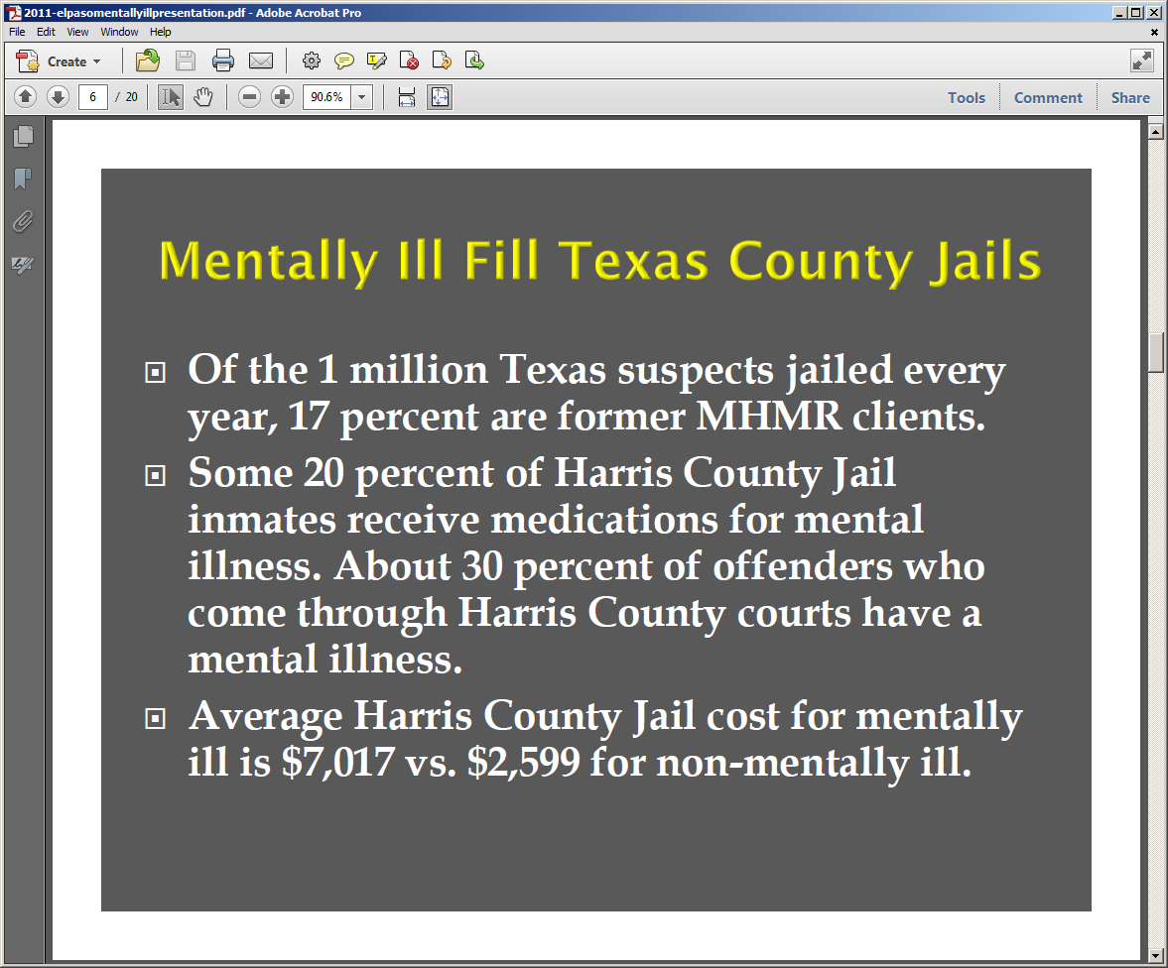
Officials here in Texas are trying to make a difference Texas Governor Greg Abbott signed the Sandra Bland Act into law June 2016 and it went into effect on September 1, 2017. The law requires jailers to make an immediate determination on the mental health status of an inmate and divert those who have a mental illness or substance abuse problem to a treatment facility instead of jail. (Houston Chronicle 2017). One senior lecturer at the University of Texas School of Law and UT Lyndon B. Johnson School of Public Affairs stated that the new law has the potential to improve the care of individuals with mental illnesses and substance abuse issues in Texas jails, as well as increase the safety of all inmates. This new state law was named after a woman who was arrested, jailed, and later committed suicide. It was only revealed later that she suffered from a history of mental illness. Some individuals say if Bland had been evaluated and sent to a mental health facility instead of jail, she may still be alive. Occurrences like this raise questions about the need for appropriate care within the criminal justice system.

 | Apr  2017 | May  2017 | Jun  2017 | July  2017 | Aug  2017 | Sep  2017 | Oct  2017 | Nov  2017 | Dec  2017 | Jan  2018 | Feb  2018 | Mar  2018 | AVERAGE
MILD | 352 | 354 | 362 | 285 | 286 | 249 | 267 | 236 | 304 | 315 | 296 | 293 | 300
MODER. | 401 | 374 | 363 | 464 | 405 | 435 | 456 | 349 | 308 | 352 | 316 | 390 | 384
SEVERE | 78 | 121 | 69 | 59 | 52 | 68 | 64 | 61 | 71 | 65 | 51 | 77 | 70
TOTAL  PSY | 831 | 849 | 794 | 808 | 753 | 752 | 787 | 646 | 683 | 732 | 663 | 760 | 755
ndividuals often experience substance abuse and mental illness simultaneously, and although it’s not always clear which one came first, the two are closely related. The presence of a mental disorder and a substance abuse disorder is called a coexisting condition and the two are closely related. According to the Substance Abuse and Mental Health Services Administration’s (SAMHSA’S) 2014 National Survey on Drug Use and Health, an estimated 7.9 people had both a mental disorder and substance use disorder. Additionally, in state prisons, 73 percent of women and 55 percent of men have at least one mental health problem. Substance abuse and mental disorders may coexist in these environments because they share many risk factors, including:
- Experiencing traumatic events in childhood or adolescence
- Poverty
- Witnessing violence or sexual abuse within the home
- Lack of parental stability
- Family history of addiction or mental illness
In many instances, men and women will resort to drugs and alcohol to numb feelings of anxiety, pain, or fear. Additionally, some will use drugs to cope with the symptoms of the mental illness they may or may not know they have. But how do these individuals end up in jail? Like my brother, some men and women will turn to property crime, prostitution, or other illegal activities to pay for their addiction. These crimes frequently escalate into violent offenses and they wind up in jail, with no access to a drug or alcohol rehabilitation program for their mental health problems or substance abuse problems.
The Sandra Bland Act directly addresses one of the major problems within the criminal justice system. Currently, there is a lack of protocol for the proper screening and assessing of incarcerated individuals to determine whether or not they need treatment for a mental health or substance abuse problem. According to SAMHSA, an effective screening process within the criminal justice system should include the following components:
- Entry points should require routine screenings for incarcerated individuals
- Standardized instruments should be used to determine if an individual needs to return for a follow-up assessment
- Facilities should have trained staff to implement and manage the screening process
- Staff should have a planned and appropriate response for incarcerated individuals who are experiencing a behavioral health crisis
- Accurate healthcare records should be kept by the agency performing the screenings
Research shows that integrated treatment is an effective approach to treating clients who suffer from substance abuse problems and disorders such as depression and anxiety. Therefore, individuals suffering from coexisting conditions (including those who are incarcerated) should be treated with an integrated approach that addresses both the substance abuse and the mental disorder(s). The main benefits of integrated drug and alcohol rehab programs are that they are associated with lower costs and better outcomes. These outcomes may include:
- Higher quality of life
- Improved functioning
- Reduced substance abuse
- Decreased hospitalization and arrests
In my opinion, integrated treatment within jails and, after release, within alcohol and drug rehab centers should involve integrated medications for both mental health problems and substance abuse issues (when applicable) and use an appropriate blend of behavioral therapies. Laws such as the recently implemented Sandra Bland Act are stirring more discussion about the need for substance abuse and mental health problems within the criminal justice system. This particular piece of legislation may help to improve access to rehabilitation centers after release for this type of treatment and subsequently protect incarcerated individuals from the dangerous consequences of their own behavioral health crises or those of others.
Regardless of this new law in Texas, those who have already been released from jail may not have ever received the addiction treatment and recovery services they needed to overcome their addiction. Somehow, it is supposed that everything will work out for the recently released, mentally impaired person. All we can continue to do is make sure the information is available for those that are seeking help for themselves or their loved ones. The National Alliance on Mental Illness (NAMI) is one such resource that provides updated information on drug and alcohol treatment, breaking news, advocacy, and support. There is no solution available that is going to be the be-all end-all solution to the problem. It is going to take an ongoing collaborative effort between the inmates, families, communities, cities, counties, and the state to deal with this as we go forward, so I think there is still a lot more work to be done.

References
http://tdcj.state.tx.us/
https://www.centerforhealthjournalism.org/2017/02/13/stepping-confront-mental-illness-jails
https://www.nami.org/

